Resources Blueprint Documentation

1-Direct Link Reference

Template Knowledge Base

✅ What does Direct Link Reference
# Source: AI Source: Provided by: [Data Path: Persons Table -> ID Column: 1, Name_En Column: Motasem Essam] -> From: [ChatGPT] on [7/14/2025]
Direct Link Reference simply means a way to directly show a web link (URL) in your documentation so anyone reading it can immediately access the page or resource.
Key Points:
- “Direct” → You write the full link exactly as it is, without shortening, hiding, or changing it.
- “Reference” → You are using it to point to a resource (like a login page, dashboard, or bug report) for others to find or verify.

Rules and Guidelines

1-Direct Link Reference
# Source: AI Source: Provided by: [Data Path: Persons Table -> ID Column: 1, Name_En Column: Motasem Essam] -> From: [ChatGPT] on [7/14/2025]
- To reference any web page, portal, or online resource, simply write it as a direct link.
- No extra formatting or path manipulation is required.
- This keeps links clear, standardized, and easy to access.
Format:
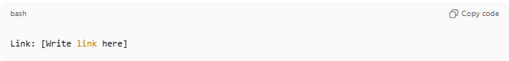
Link: [Write link here]
Example:
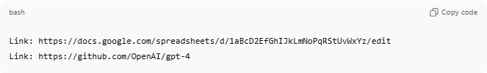
Link: https://docs.google.com/spreadsheets/d/1aBcD2EfGhIJkLmNoPqRStUvWxYz/edit
Link: https://github.com/OpenAI/gpt-4
Usage Notes:
- Always start with Link: to indicate it’s a clickable or reference URL.
- Works for login pages, dashboards, bug reports, documents, or any online resource.
- Keep the URL complete and accurate to avoid broken links.

2-Source Metadata Template

Knowledge Base

1-What is Source Metadata Template?
# Source: AI Source: Provided by: [Data Path: Persons Table -> ID Column: 1, Name_En Column: Motasem Essam] -> From: [ChatGPT] on [7/14/2025]
- Source = any item you captured, saved, or created, whether digital (PDF, image, video, webpage) or physical (scanned document, recorded audio/video, photographed material).
- Metadata = structured information about that source — such as its type, domain, platform, storage, acquisition method, format, quality, and acquisition date.
- Template = a ready-to-use structure or form where you can fill in all metadata fields consistently for each source.

2-what is Content Acquisition Log?
# Source: AI Source: Provided by: [Data Path: Persons Table -> ID Column: 1, Name_En Column: Motasem Essam] -> From: [ChatGPT] on [4/15/2026]
A Content Acquisition Log is a structured record that tracks how a file, resource, or content was obtained, processed, and stored in your system.
📌 In simple terms
It answers:
- What did you get? → (file, image, document, etc.)
- How did you get it? → (downloaded, converted, scraped, etc.)
- Using what? → (browser, tool, API, etc.)
- Who did it? → (person responsible)
- When? → (date/time)
🎯 Purpose
The Content Acquisition Log is used to:
- Track source and origin of content
- Ensure data transparency and traceability
- Document tools and methods used
- Help with auditing and validation
- Organize digital assets systematically

Rules and Guidelines

1- Source Metadata Template
# Source: AI Source: Provided by: [Data Path: Persons Table -> ID Column: 1, Name_En Column: Motasem Essam] -> From: [ChatGPT] on [7/14/2025]
- Each field name (like “Content Title”, “Content Type”, etc.) is preceded by a single * (star).
- Each field name is bolded for clarity.
- A clear note is added at the end explaining that you can add more fields if needed.
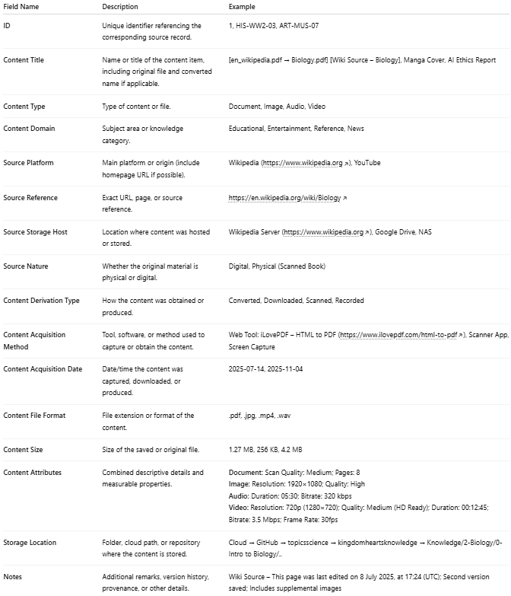

Field Name | Description | Example
ID | Unique identifier referencing the corresponding source record. | 1, HIS-WW2-03, ART-MUS-07
Content Title | Name or title of the content item, including original file and converted name if applicable. | [en_wikipedia.pdf → Biology.pdf] [Wiki Source – Biology], Manga Cover, AI Ethics Report
Content Type | Type of content or file. | Document, Image, Audio, Video
Content Domain | Subject area or knowledge category. | Educational, Entertainment, Reference, News
Source Platform | Main platform or origin (include homepage URL if possible). | Wikipedia (https://www.wikipedia.org), YouTube
Source Reference | Exact URL, page, or source reference. | https://en.wikipedia.org/wiki/Biology
Source Storage Host | Location where content was hosted or stored. | Wikipedia Server (https://www.wikipedia.org), Google Drive, NAS
Source Nature | Whether the original material is physical or digital. | Digital, Physical (Scanned Book)
Content Derivation Type | How the content was obtained or produced. | Converted, Downloaded, Scanned, Recorded
Content Acquisition Method | Tool, software, or method used to capture or obtain the content. | Web Tool: iLovePDF – HTML to PDF (https://www.ilovepdf.com/html-to-pdf), Scanner App, Screen Capture
Content Acquisition Date | Date/time the content was captured, downloaded, or produced. | 2025-07-14, 2025-11-04
Content File Format | File extension or format of the content. | .pdf, .jpg, .mp4, .wav
Content Size | Size of the saved or original file. | 1.27 MB, 256 KB, 4.2 MB
Content Attributes | Combined descriptive details and measurable properties. | Document: Scan Quality: Medium; Pages: 8  Image: Resolution: 1920×1080; Quality: High  Audio: Duration: 05:30; Bitrate: 320 kbps  Video: Resolution: 720p (1280×720); Quality: Medium (HD Ready); Duration: 00:12:45; Bitrate: 3.5 Mbps; Frame Rate: 30fps
Storage Location | Folder, cloud path, or repository where the content is stored. | Cloud → GitHub → topicsscience → kingdomheartsknowledge → Knowledge/2-Biology/0-Intro to Biology/..
Notes | Additional remarks, version history, provenance, or other details. | Wiki Source – This page was last edited on 8 July 2025, at 17:24 (UTC); Second version saved; Includes supplemental images

🏷 Content Title:
# Source: AI Source: Provided by: [Data Path: Persons Table -> ID Column: 1, Name_En Column: Motasem Essam] -> From: [ChatGPT] on [7/14/2025]
This field specifies the title and filename of the content item.
It typically includes:
- The original file name (as initially saved or exported).
- The final file name (after renaming for organization).
- an additional display or web title for easier reference.
💡 Example:
[pupa_fandom_com_wiki_Manga.pdf → Pupa Manga Overview.pdf] [Pupa Manga – Fandom Wiki Page]
(Shows that the file was originally saved as “pupa_fandom_com_wiki_Manga.pdf”, renamed to “Pupa Manga Overview.pdf”, and includes the source page title for context.)

📝 Note:
You can add multiple rename sequences if the file was renamed several times for clarity or organization — for example:
[pupa_fandom_com_wiki_Manga.pdf → Manga_Pupa_Article.pdf → Pupa Manga Overview.pdf]

🗄️ Source Storage Host:
# Source: AI Source: Provided by: [Data Path: Persons Table -> ID Column: 1, Name_En Column: Motasem Essam] -> From: [ChatGPT] on [7/14/2025]
This field identifies where the content is currently stored or hosted, regardless of its original source.
It can include online servers, cloud storage, local devices, or network-attached storage, and reflects the final or current location of the content.

Always write:
https://<full-storage-path> [Storage Name or Mirror Role]
💡 Example
- Locally Stored on Device [Huawei Y7 Prime 2019 – Mobile Scan Folder]
- https://github.com/animekingdomelbaf/kingdomheartsManga/tree/main/Manga/Pupa [GitHub Cloud Repository]
- https://mega.nz/folder/ABC123 [MEGA Cloud Backup Mirror]
- NAS-Archive-01 [Primary Storage Server]
- D:\Knowledge\Videos\Egypt\ [Local Storage]

📘 Rules & Notes
- Full Path or URL:
Always provide the complete path or URL when available.
Online example: https://drive.google.com/drive/folders/123ABC [Google Drive Mirror]
Local example: D:\Knowledge\Videos\Egypt\ [Local Storage]
- Local or Internal Storage:
Clearly specify the device, server, or folder name for locally stored content.
- Multiple Locations or Mirrors:
If content exists in multiple locations, list them in order of priority.
Example: https://mega.nz/folder/ABC123 [MEGA Mirror], https://github.com/... [GitHub Backup]
- Mirror/Storage Role (Optional):
You may specify roles like [Primary Storage], [Backup Mirror], [Cloud Archive], etc.
- Consistency Rule:
  - Online storage → full URL + role
  - Offline storage → full path + clear label [Local Storage]

⚙️ Content Acquisition Method:
# Source: AI Source: Provided by: [Data Path: Persons Table -> ID Column: 1, Name_En Column: Motasem Essam] -> From: [ChatGPT] on [7/14/2025]
This field describes how the content was obtained, captured, or generated, including any tools, applications, or processes used.
It applies to digital downloads, conversions, scans of physical materials, recordings, or any capture method.

Include:
• The name of the tool, software, or device (e.g., scanner, camera, audio recorder, web app, script).
• The URL, platform, or manufacturer (if applicable).
• A brief note on its purpose or function (e.g., “used to convert a webpage into a PDF” or “scanned textbook page”).
• Optionally, include a link if the tool, platform, or device has an accessible reference page.

💡 Example:
- Web Tool: Sejda HTML-to-PDF (https://www.sejda.com/html-to-pdf) [Used to convert the webpage into a PDF document]
- Scanner: Canon LiDE 300 [Used to scan textbook pages into high-resolution images]
- Recorder: Zoom H5 Audio Recorder [Captured interview audio in WAV format]

📝 Note:
You can list multiple acquisition methods or steps if more than one tool or process was used. For example:
- Browser Extension: Image Downloader [to save images] → Application: Adobe Acrobat [to combine images into a single PDF]
- Camera: Sony Alpha 7C [Photographed reference material] → Scanner: Epson Perfection V600 [Digitized pages]

💾 Storage Location:
# Source: AI Source: Provided by: [Data Path: Persons Table -> ID Column: 1, Name_En Column: Motasem Essam] -> From: [ChatGPT] on [7/14/2025]
This field indicates where the content is stored — whether on a local device, external drive, cloud, network server, or physical archive.
It uses a compact, inline format for quick readability, while allowing multiple storage locations when applicable.

Include:
• The main storage path, device, or folder where the content is saved.
• Any secondary or backup locations, separated by a vertical bar |.
• Labels such as Local, Cloud, Backup, Archive, or Device for clarity.

💡 Example:
- Local: KINGSTON Games (F:)/Games/Commandos/ | Cloud: Google Drive /DevDocs/Reports | Notes: Shared project documentation
- Local: D:/Knowledge/Books/ | Cloud: GitHub/kingdomheartsknowledge/Knowledge/Books/
- Device: Huawei Y7 Prime 2019 – Mobile Scan Folder | Backup: NAS-Archive-01 [Primary Storage Server]

📝 Notes:
- Priority Order: List the primary location first, then backups or mirrors.
- Single Location: If only one location exists, omit the separator and backup section.
- Full Paths: Always include complete directory paths or device/folder names; avoid vague references.
- Clarity Tags: Use clear identifiers for each storage type, e.g., Local, Cloud, Backup, Archive, or Device.
- Consistency: Apply the same inline format for all records to ensure uniformity and readability.

Attachments (Optional)
Attachments are images stored in a dedicated attachments/ folder located inside the same folder as the main source file. The source folder contains the main file (e.g., Sources - Intro to biology - Wiki Source.docx) and the attachments/ subfolder where all supporting images are stored.
Rules
- Attachments are optional.
- Typically used for images only (.jpg, .png, .webp).
- Listed at the end of the metadata record.
- Attachments can has also source file but it not add to source table
- Each attachment should include a short description and filename or path.
- Attachments do not replace the main source file.
- You can also add attachments inside the main source file itself if needed (e.g., embedded images in DOCX or PDF).
Attachments Format
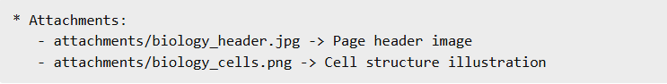
* Attachments:
- attachments/biology_header.jpg -> Page header image
- attachments/biology_cells.png -> Cell structure illustration

Attachment Storage Rule
- All attachments are stored inside the same source container
- Specifically in a dedicated folder named: attachments/

- Attachments are:
  - Images only (.jpg, .png, .webp)
  - Support material, not primary content
  - Referenced relatively, not by absolute external paths

Folder Structure
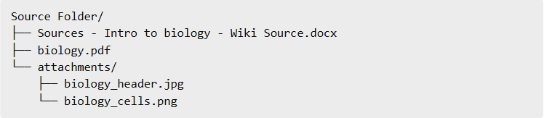
Source Folder/
├── Sources - Intro to biology - Wiki Source.docx
├── biology.pdf
└── attachments/
├── biology_header.jpg
└── biology_cells.png

Format
# Source: AI Source: Provided by: [Data Path: Persons Table -> ID Column: 1, Name_En Column: Motasem Essam] -> From: [ChatGPT] on [7/14/2025]
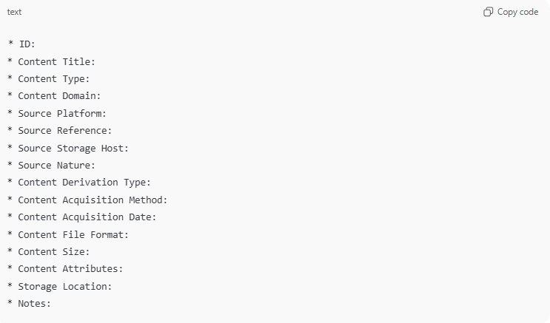
* ID:
* Content Title:
* Content Type:
* Content Domain:
* Source Platform:
* Source Reference:
* Source Storage Host:
* Source Nature:
* Content Derivation Type:
* Content Acquisition Method:
* Content Acquisition Date:
* Content File Format:
* Content Size:
* Content Attributes:
* Storage Location:
* Notes:

Example
# Source: AI Source: Provided by: [Data Path: Persons Table -> ID Column: 1, Name_En Column: Motasem Essam] -> From: [ChatGPT] on [7/14/2025]
1️⃣ Source without attachments
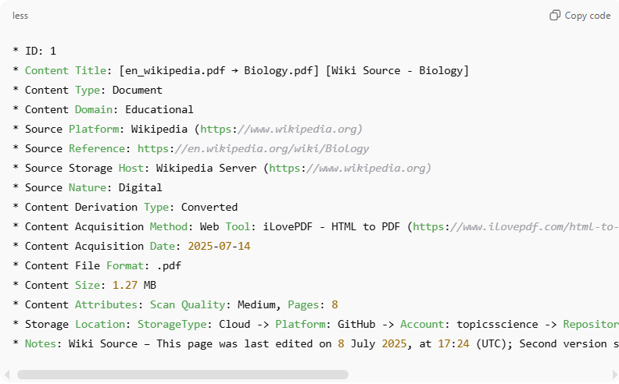
* ID: 1
* Content Title: [en_wikipedia.pdf → Biology.pdf] [Wiki Source - Biology]
* Content Type: Document
* Content Domain: Educational
* Source Platform: Wikipedia (https://www.wikipedia.org)
* Source Reference: https://en.wikipedia.org/wiki/Biology
* Source Storage Host: Wikipedia Server (https://www.wikipedia.org)
* Source Nature: Digital
* Content Derivation Type: Converted
* Content Acquisition Method: Web Tool: iLovePDF - HTML to PDF (https://www.ilovepdf.com/html-to-pdf)
* Content Acquisition Date: 2025-07-14
* Content File Format: .pdf
* Content Size: 1.27 MB
* Content Attributes: Scan Quality: Medium, Pages: 8
* Storage Location: StorageType: Cloud -> Platform: GitHub -> Account: topicsscience -> Repository: kingdomheartsknowledge -> Path: Knowledge/2-Biology/0-Intro to Biology/..
* Notes: Wiki Source – This page was last edited on 8 July 2025, at 17:24 (UTC); Second version saved; Includes supplemental images

2️⃣ Source with attachments
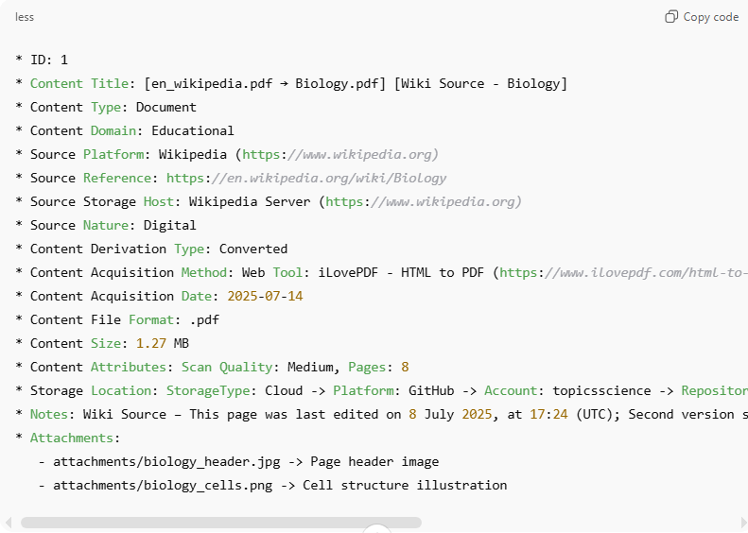
* ID: 1
* Content Title: [en_wikipedia.pdf → Biology.pdf] [Wiki Source - Biology]
* Content Type: Document
* Content Domain: Educational
* Source Platform: Wikipedia (https://www.wikipedia.org)
* Source Reference: https://en.wikipedia.org/wiki/Biology
* Source Storage Host: Wikipedia Server (https://www.wikipedia.org)
* Source Nature: Digital
* Content Derivation Type: Converted
* Content Acquisition Method: Web Tool: iLovePDF - HTML to PDF (https://www.ilovepdf.com/html-to-pdf)
* Content Acquisition Date: 2025-07-14
* Content File Format: .pdf
* Content Size: 1.27 MB
* Content Attributes: Scan Quality: Medium, Pages: 8
* Storage Location: StorageType: Cloud -> Platform: GitHub -> Account: topicsscience -> Repository: kingdomheartsknowledge -> Path: Knowledge/2-Biology/0-Intro to Biology/..
* Notes: Wiki Source – This page was last edited on 8 July 2025, at 17:24 (UTC); Second version saved; Includes supplemental images
* Attachments:
- attachments/biology_header.jpg -> Page header image
- attachments/biology_cells.png -> Cell structure illustration

2-Source Quality

Source Quality for pdf
# Source: AI Source: Provided by: [Data Path: Persons Table -> ID Column: 1, Name_En Column: Motasem Essam] -> From: [ChatGPT] on [7/14/2025]
✅ Suggestions for Source Quality values:
Here are common options you can choose from based on your result:
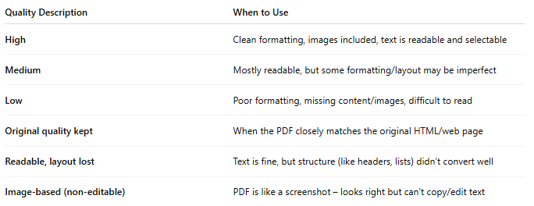
Quality Description | When to Use
High | Clean formatting, images included, text is readable and selectable
Medium | Mostly readable, but some formatting/layout may be imperfect
Low | Poor formatting, missing content/images, difficult to read
Original quality kept | When the PDF closely matches the original HTML/web page
Readable, layout lost | Text is fine, but structure (like headers, lists) didn’t convert well
Image-based (non-editable) | PDF is like a screenshot – looks right but can't copy/edit text

📌 Example for your case:
If your PDF looks nearly identical to the Wikipedia page and all content is clear:
Source Quality: High – original formatting preserved, text selectable.
If some formatting broke (e.g., images misplaced, links missing):
Source Quality: Medium – readable but layout partially broken.
Would you like me to review or help rate a specific file's quality if you upload it?

layout partially broken
When we say “layout partially broken,” it means the structure or appearance of the page didn’t fully survive the conversion from HTML to PDF. This can include several types of issues:

📌 What "layout partially broken" can mean:
- Extra white space or unnecessary height/length added
- Misaligned sections (e.g., text that was beside an image now appears below it)
- Overlapping content
- Lost column formatting
- Headers/footers in the wrong place
- Table of contents or navigation menus showing up awkwardly

✅ In your case:
If the converted PDF has longer pages, more height, and seems stretched compared to the website — yes, this is one form of "layout partially broken".
So your Content Quality could be written like this:
Content Quality: Medium – readable, but layout partially broken (excess page height)

Source Quality for Image
# Source: AI Source: Provided by: [Data Path: Persons Table -> ID Column: 1, Name_En Column: Motasem Essam] -> From: [ChatGPT] on [7/14/2025]
🖼️ Image Quality Levels
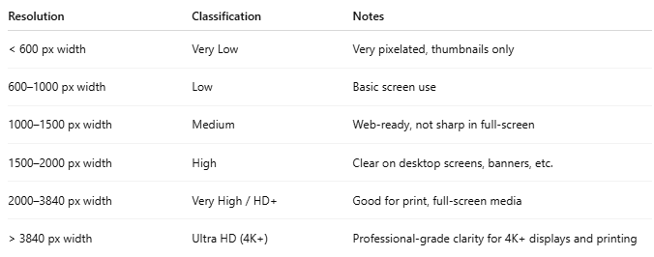
Resolution | Classification | Notes
< 600 px width | Very Low | Very pixelated, thumbnails only
600–1000 px width | Low | Basic screen use
1000–1500 px width | Medium | Web-ready, not sharp in full-screen
1500–2000 px width | High | Clear on desktop screens, banners, etc.
2000–3840 px width | Very High / HD+ | Good for print, full-screen media
> 3840 px width | Ultra HD (4K+) | Professional-grade clarity for 4K+ displays and printing

📌 Notes:
- Resolution = width × height in pixels
- File format matters too:
  - .jpg is lossy, smaller size
  - .png is lossless, supports transparency
  - .webp is optimized for the web
  - .tiff and .raw are used in professional imaging

✅ Sample Labels You Can Use:
You can assign quality in your system like this:
- Very Low
- Low
- Medium
- High
- Very High
- Ultra HD / 4K
- Custom (for unusual formats or dimensions)

Source Quality for Video
# Source: AI Source: Provided by: [Data Path: Persons Table -> ID Column: 1, Name_En Column: Motasem Essam] -> From: [ChatGPT] on [7/14/2025]
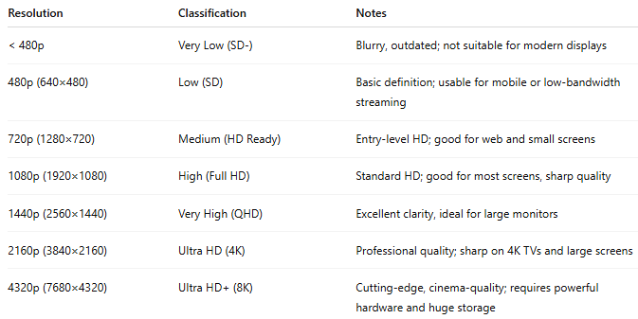
Resolution | Classification | Notes
< 480p | Very Low (SD-) | Blurry, outdated; not suitable for modern displays
480p (640×480) | Low (SD) | Basic definition; usable for mobile or low-bandwidth streaming
720p (1280×720) | Medium (HD Ready) | Entry-level HD; good for web and small screens
1080p (1920×1080) | High (Full HD) | Standard HD; good for most screens, sharp quality
1440p (2560×1440) | Very High (QHD) | Excellent clarity, ideal for large monitors
2160p (3840×2160) | Ultra HD (4K) | Professional quality; sharp on 4K TVs and large screens
4320p (7680×4320) | Ultra HD+ (8K) | Cutting-edge, cinema-quality; requires powerful hardware and huge storage

Source Quality for Games
# Source: AI Source: Provided by: [Data Path: Persons Table -> ID Column: 1, Name_En Column: Motasem Essam] -> From: [ChatGPT] on [7/14/2025]
For games, "Download Quality" typically refers to aspects like:
✅ Common Ways to Define Download Quality for Games:
- Resolution/Graphics Assets Quality
  - High – Includes high-resolution textures, models, effects
  - Medium – Balanced for performance and visuals
  - Low – Optimized for low-end systems, reduced graphics fidelity
- Edition Type
  - Standard, Deluxe, Ultimate, or Definitive (as in your case)
  - Affects content like DLCs, expansions, bonus content
- File Integrity
  - Verified, Corrupt-Free, Official Source
- Performance Suitability
  - Optimized for system, Smooth performance, etc.

3-Content Acquisition Log

Rules for Writing Content Acquisition Log Entries
# Source: AI Source: Provided by: [Data Path: Persons Table -> ID Column: 1, Name_En Column: Motasem Essam] -> From: [ChatGPT] on [4/15/2026]
Enter Number → User Information → Timestamp → Action Type → Method → Tool Information

1. Entry Number
- Each entry starts with a sequential number indicating its order in the log.
- Format:
1 -> or 2 ->

2. User Information
- Include the full reference of the person performing the action.
- Format:
Data Path: Persons Table -> ID Column: [ID], Name_En Column: [Name]

3. Timestamp
- Record the date and time of the action.
- Format:
MM/DD/YYYY HH:MM:SS AM/PM (time optional)

4. Action Type
- Specify the acquisition action performed:
- Downloaded → file saved from a source
- Converted → file transformed (e.g., HTML → PDF)
- Scraped → extracted using script/tool
- Captured → screenshot or manual capture
- Generated → created using software or AI

5. Method
- Define how the action was performed:
  - Web Browser
  - Web App
  - API
  - Script
  - Manual
  - Desktop Software

6. Tool Information
- Provide details about the tool used.
Format:
- Name: [Tool Name]
- URL: [Link] (optional)
- Type: [Extra detail] (optional)

7. File Details (Optional)
- Additional metadata about the file.
Format:
- File Name: [Name]
- File Type: [Type]
- File Size: [Size]

Examples
# Source: AI Source: Provided by: [Data Path: Persons Table -> ID Column: 1, Name_En Column: Motasem Essam] -> From: [ChatGPT] on [4/15/2026]
1. Basic Download
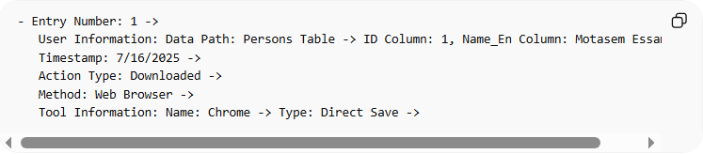
- Entry Number: 1 ->
User Information: Data Path: Persons Table -> ID Column: 1, Name_En Column: Motasem Essam ->
Timestamp: 7/16/2025 ->
Action Type: Downloaded ->
Method: Web Browser ->
Tool Information: Name: Chrome -> Type: Direct Save ->

2. Conversion
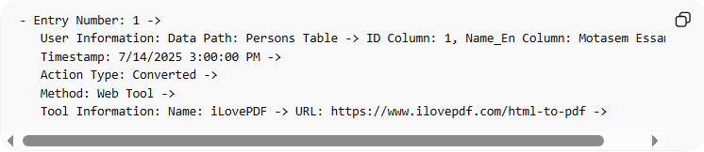
- Entry Number: 1 ->
User Information: Data Path: Persons Table -> ID Column: 1, Name_En Column: Motasem Essam ->
Timestamp: 7/14/2025 3:00:00 PM ->
Action Type: Converted ->
Method: Web Tool ->
Tool Information: Name: iLovePDF -> URL: https://www.ilovepdf.com/html-to-pdf ->

3-AvailabilityDetails Metadata Template

Template Knowledge Base

✅ What does " AvailabilityDetails Metadata Templat" mean?
# Source: AI Source: Provided by: [Data Path: Persons Table -> ID Column: 1, Name_En Column: Motasem Essam] -> From: [ChatGPT] on [7/14/2025]
The "AvailabilityDetails Metadata Template" is essentially a structured format or table that helps you record and organize detailed information about the accessibility of a resource or link.
Think of it as a mini-database for tracking whether a file, link, or document is available and any conditions or observations related to its accessibility.

Rules and Guidelines

1-AvailabilityDetails Metadata Template
# Source: AI Source: Provided by: [Data Path: Persons Table -> ID Column: 1, Name_En Column: Motasem Essam] -> From: [ChatGPT] on [7/14/2025]
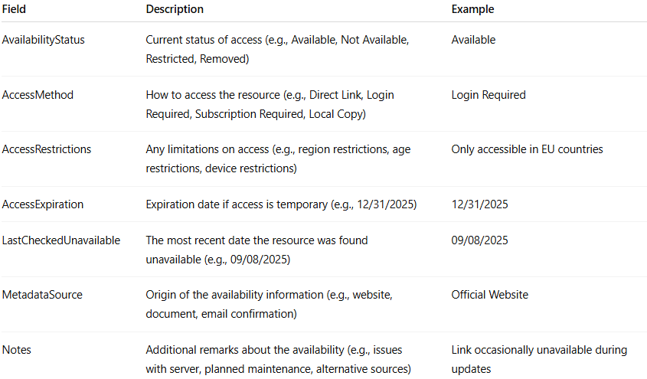
Field | Description | Example
AvailabilityStatus | Current status of access (e.g., Available, Not Available, Restricted, Removed) | Available
AccessMethod | How to access the resource (e.g., Direct Link, Login Required, Subscription Required, Local Copy) | Login Required
AccessRestrictions | Any limitations on access (e.g., region restrictions, age restrictions, device restrictions) | Only accessible in EU countries
AccessExpiration | Expiration date if access is temporary (e.g., 12/31/2025) | 12/31/2025
LastCheckedUnavailable | The most recent date the resource was found unavailable (e.g., 09/08/2025) | 09/08/2025
MetadataSource | Origin of the availability information (e.g., website, document, email confirmation) | Official Website
Notes | Additional remarks about the availability (e.g., issues with server, planned maintenance, alternative sources) | Link occasionally unavailable during updates

4-Resources Format

Template Knowledge Base

✅ What is Resources Format
# Source: AI Source: Provided by: [Data Path: Persons Table -> ID Column: 1, Name_En Column: Motasem Essam] -> From: [ChatGPT] on [7/14/2025]
The “Resources Format Rule” is a standard guideline that defines how to describe and record resources (like tools, APIs, documentation, datasets, libraries, or tutorials) in a consistent one-line format across your system or templates.

Purpose:
Defines a standardized way to describe resources (documentation, tools, libraries, APIs, tutorials, datasets, references, etc.) linked to a task, system, or project.
It ensures every resource entry follows a unified structure that captures its type, location, author, and purpose, improving traceability, consistency, and reuse across projects.

Rules and Guidelines

1-Resources Format
# Source: AI Source: Provided by: [Data Path: Persons Table -> ID Column: 1, Name_En Column: Motasem Essam] -> From: [ChatGPT] on [7/14/2025]
Format (One Line):
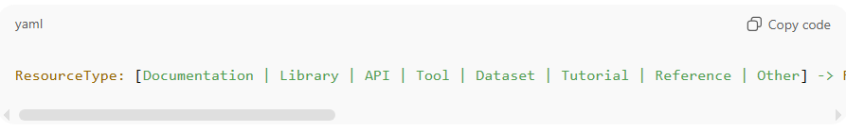
ResourceType: [Documentation | Library | API | Tool | Dataset | Tutorial | Reference | Other] -> ResourceLinkOrPath: [URL or File Path] -> AddedBy: [Username or Email] -> AddedDate: [YYYY-MM-DD or DateTime] -> Notes: [Purpose, usage notes, or remarks]

💡 Examples (One Line Each):
📘 Documentation Example
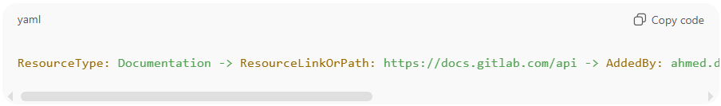
ResourceType: Documentation -> ResourceLinkOrPath: https://docs.gitlab.com/api -> AddedBy: ahmed.dev@company.com -> AddedDate: 2025-10-12 -> Notes: Used for integrating GitLab API endpoints
⚙️ Library Example
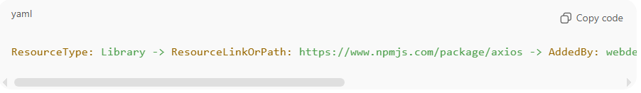
ResourceType: Library -> ResourceLinkOrPath: https://www.npmjs.com/package/axios -> AddedBy: webdev@company.com -> AddedDate: 2025-10-12 -> Notes: HTTP client for backend requests
🔧 Tool Example
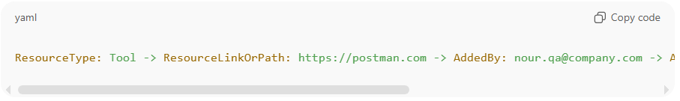
ResourceType: Tool -> ResourceLinkOrPath: https://postman.com -> AddedBy: nour.qa@company.com -> AddedDate: 2025-10-11 -> Notes: Used for testing API endpoints

✅ Key Field Definitions
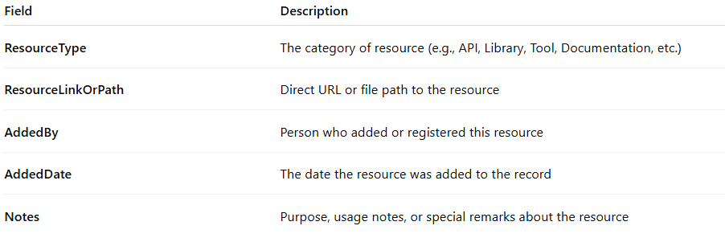
Field | Description
ResourceType | The category of resource (e.g., API, Library, Tool, Documentation, etc.)
ResourceLinkOrPath | Direct URL or file path to the resource
AddedBy | Person who added or registered this resource
AddedDate | The date the resource was added to the record
Notes | Purpose, usage notes, or special remarks about the resource

📘 Summary Table
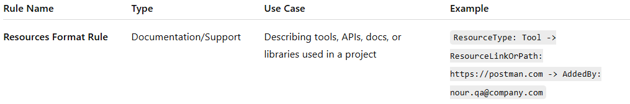
Rule Name | Type | Use Case | Example
Resources Format Rule | Documentation/Support | Describing tools, APIs, docs, or libraries used in a project | ResourceType: Tool -> ResourceLinkOrPath: https://postman.com -> AddedBy: nour.qa@company.com

5-Resources Content Reference

Template Knowledge Base

✅ What is Resources Content Reference
# Source: AI Source: Provided by: [Data Path: Persons Table -> ID Column: 1, Name_En Column: Motasem Essam] -> From: [ChatGPT] on [7/14/2025]
Resources Content Reference is a standardized template or rule that defines how to reference specific content inside a resource.
It allows you to precisely point to sections, paragraphs, cells, functions, or keywords inside any resource linked to a project or task. Resources can be documents, PDFs, spreadsheets, web pages, code libraries, tools, or external links.

Purpose:
Defines how to reference specific content inside a resource (text, image, video) with optional position indicators.
- Works for any resource type: Documentation, Library, API, Tool, Dataset, Tutorial, Reference, Other.
- Allows indicating: what type of content (Text, Image, Video).
- Supports positioning keywords: before, after, left, right, top, bottom, center (especially for images).
- Integrated before AddedBy, AddedDate, Notes for precise content annotation.

Rules and Guidelines

1-Resources Content Reference
# Source: AI Source: Provided by: [Data Path: Persons Table -> ID Column: 1, Name_En Column: Motasem Essam] -> From: [ChatGPT] on [7/14/2025]
Rules:
- MediaType — Indicates what you want to reference: Text, Image, Video.
- Keyword — Optional, can be used for Text, Image, or Video to point to a specific word, visual element, or clip.
- Location — Section/Paragraph/Cell for Text, Region for Image, Start Time for Video.
- Position — Only for Text or Image, options: before, after, at. Video does not use Position.
- AddedBy, AddedDate, Notes — Always at the end.

Format (One Line)
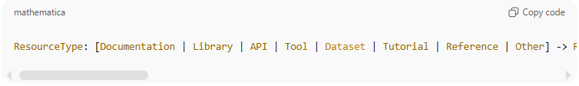
ResourceType: [Documentation | Library | API | Tool | Dataset | Tutorial | Reference | Other] -> ResourceLinkOrPath: [URL or File Path] -> MediaType: [Text | Image | Video] -> Keyword: [Optional, Text/Image/Video] -> Position: [before | after | at] -> Location: [Section/Paragraph/Cell/Region/Time] -> AddedBy: [Username or Email] -> AddedDate: [YYYY-MM-DD or DateTime] -> Notes: [Purpose, usage notes, or remarks]

Notes:
- Keyword works for all MediaTypes, optional.
- Position only applies to Text or Image.
- Video uses only Location: Start Time.

Examples (One Line, Grey Background)
Text with Keyword and Position
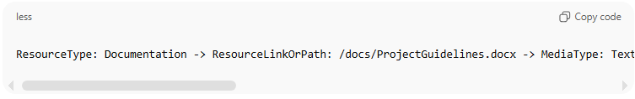
ResourceType: Documentation -> ResourceLinkOrPath: /docs/ProjectGuidelines.docx -> MediaType: Text -> Keyword: "approvedAds" -> Position: after -> Location: Section 3.2, Paragraph 4 -> AddedBy: ahmed.dev@company.com -> AddedDate: 2025-10-10 -> Notes: Approved ads workflow

Image with Region and Position
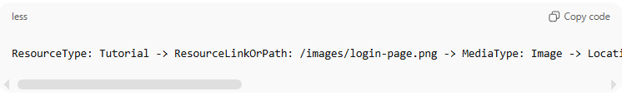
ResourceType: Tutorial -> ResourceLinkOrPath: /images/login-page.png -> MediaType: Image -> Location: 120,80,300,400 -> Position: at center of login form -> AddedBy: team.storage@company.com -> AddedDate: 2025-10-11 -> Notes: Highlighted login form elements

Video with Keyword and Time (no Position)
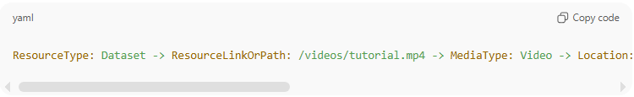
ResourceType: Dataset -> ResourceLinkOrPath: /videos/tutorial.mp4 -> MediaType: Video -> Location: 00:02:15 -> AddedBy: team.storage@company.com -> AddedDate: 2025-10-11 -> Notes: Demonstration clip for ad approval

Spreadsheet Cell with Keyword and Position
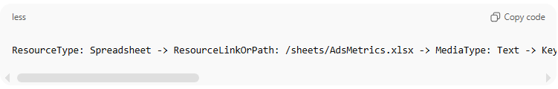
ResourceType: Spreadsheet -> ResourceLinkOrPath: /sheets/AdsMetrics.xlsx -> MediaType: Text -> Keyword: "ConversionRate" -> Position: before -> Location: Sheet "2025-Q3", Cells B2:D10 -> AddedBy: team.storage@company.com -> AddedDate: 2025-10-09 -> Notes: Weekly ad performance data

✅ Summary of Rules:
- MediaType: Text | Image | Video
- Keyword: Optional, works for all MediaTypes except Video
- Location: Section/Paragraph/Cell (Text), Region (Image), Time (Video)
- Position: before | after | at (Text, Image only)
- AddedBy, AddedDate, Notes: Always last

